1A. Graph for Percent Purchased Vs Price 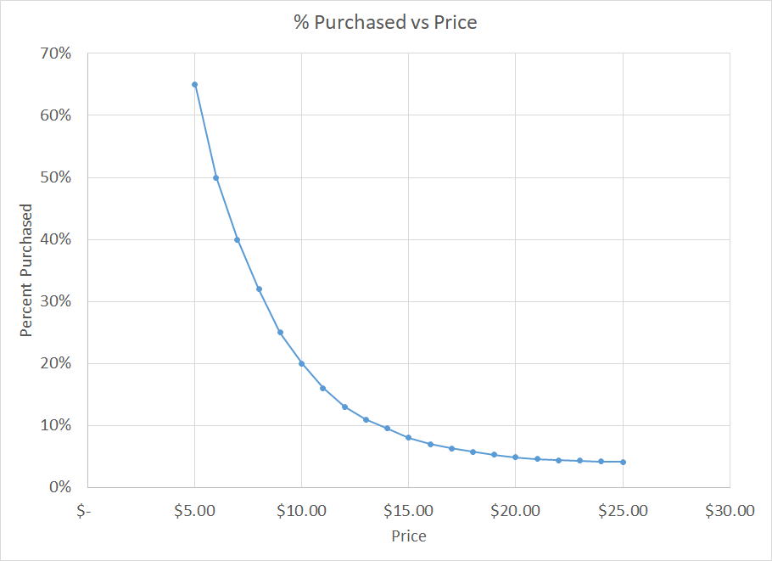

1B. Power Regression to determine predicted values.

y = 14.098x-1.872  
 R² = 0.9908

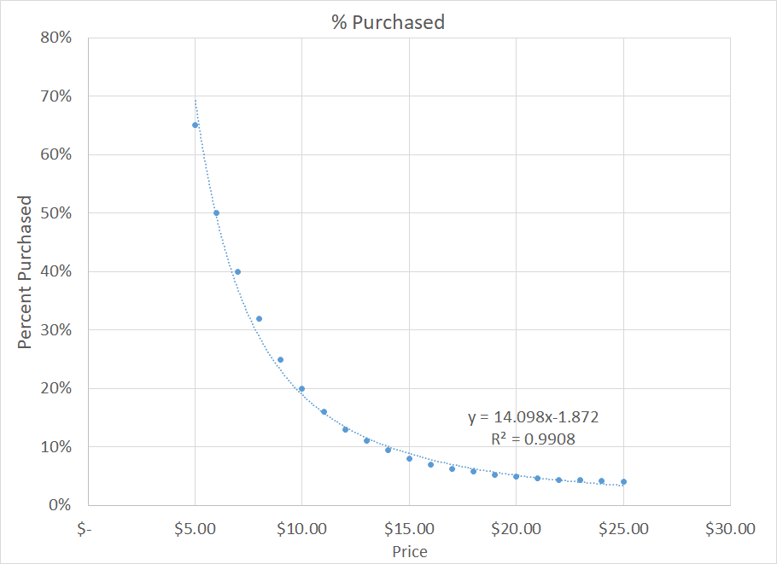



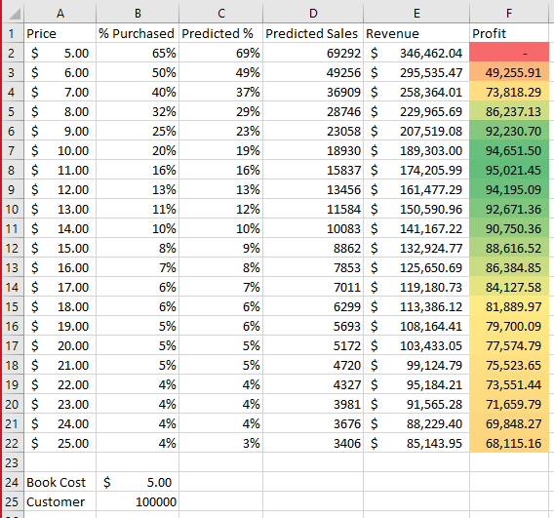

2A

For the scenario where the cost is $5 the optimal price point is 10.73. For the scenario where the cost is $4.50 and we need to sell a minimum of 30,000 copies the optimal price is $7.82. For the scenario where the cost is $4.00 and we need to sell a minimum of 50,000 copies the optimal price is $5.95.

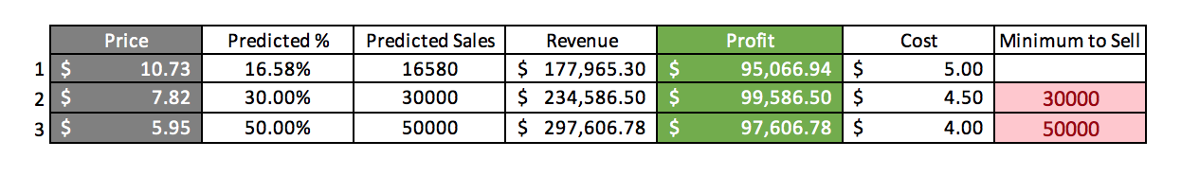

2B

Scenario #2 is the most optimal configuration of the three. Even though you need to sell a minimum of 30,000 books this model predicts you can generate a higher profit then the other two scenarios. The 2nd scenario yields a profit of $99,586.51 which is roughly $2,000 more than scenario 3 and $4,000 more than in scenario 1.

3A

A possible risk is the sequel may not be desired as much as Harry Potter 7. This could lead to purchasing patterns being driven by consumer preference rather than price point. In our previous example price was more of a driving factor and we are unable to determine if the same sample of people will take interest in the sequel. This creates to possible factors that affect sales rather than one.

3B

* Demand of Product
* Purchasing Power of Demographic
* # of people that have read a previous Harry Potter novel
* Gender of Consumer
* Age of Consumer
* Genre Preference of Consumer